**Experiences of Nurses Losing Their First Older Resident in Long-Term Care in the Greater Toronto Area**

Twinkle

Shweta Karki

Simon Kibor

Princess Lemence

Ruel Jayson Terre

Shreeya Thapa

Gerontology Interprofessional Practice, Fanshawe College

RSCH-6008 Research Literacy- Section 03

Prof. Blessing Ojembe, Ph.D.

August 6, 2024

**Introduction**

One of the health care team members who have an admirable experience in distressing situations yet maintain a professional approach are nurses, particularly in a long-term care home where nurses are in charge of their patients’ care and welfare. Furthermore, the challenging part of being a nurse is losing a patient, which can have a lasting effect on the nurses involved. First time experience of nurses in losing a patient has an impact on their careers (Elis Both et al., 2013). This affects their work, environment, personal activities, and relationships with others. Nurses may show different emotions towards the loss of their first patient, yet it is necessary for them to understand the patient's death and what to expect as part of their profession (Elis Both et al., 2013).

Furthermore, the loss of patients can have a significant impact on the nurses involved and may experience a great deal of mental distress and a decrease in job satisfaction as the result of the loss of a patient. According to studies, nurses who lose a patient may exhibit signs of anxiety, depression, and post-traumatic stress disorder (De Boer et al., 2011). Additionally, Coomber and Barriball (2007), suggests that the loss of a patient can impact a nurse’s job satisfaction, which may result in burnout and turnover. Therefore, it is crucial to understand the experiences of nurses in long-term care homes when they lose their first patient to provide appropriate support and resources. Most of the literature discusses nurses’ experiences in different clinical settings, like hospitals and community health centers. Unfortunately, there is no available literature that focuses on the experiences of nurses in losing their first patient in long-term care. Another existing gap in the literature is the tendency to make conclusions about the nurses’ experiences without considering the diversity within the nursing profession, especially in long-term care settings. Nurses working in long-term care homes come from different backgrounds with different levels of experience and training. All these circumstances can affect how they deal with losing a patient. Nurses from different cultures, education and their training might have their own unique beliefs and experiences on how they handle death. So, it is important to understand all these factors to really get to know how nurses in long-term care deal with patient loss. This understanding can help us create interventions that nurses need.

This study aimed to explore and understand the experiences of nurses in losing their first patient in a long-term care home. As gerontology interprofessional practice students, we have not experienced taking care of terminally ill patients nor witnessed a patient’s death. Hence, this study provided a comprehensive narrative of respondents that we can construct substantial insights. Likewise, substantial insights can be a basis for developing a specific program that might aid the psychological, emotional, spiritual, practices, and well-being of the nurses.

**Research Questions**

This study aimed to explore experiences of nurses losing their first older resident in a long-term care home in the Greater Toronto Area. The researchers intended to answer the following questions:

1. *What are the experiences of nurses in losing their first older resident in a long-term care home?*

2. *What ideas or concrete insights can be drawn from their experiences of losing their first resident in a long-term care home?*

**Research Strategy**

The purpose of the search strategy in a qualitative, non-experimental, and phenomenological type of study is to provide narrative that serves as the basis of the study. Comprehensive search strategy, study selection, and data extraction was developed in consultation with Prof. Blessing Ojembe, Ph.D. After the consultation, the researchers came up with a working title for the study. We utilized PubMed, Google Scholar, Journals, and Articles to support and to have a proper articulation of the nature of the study. In addition, Introduction was constructed through gathering Related literature. We utilized Medical Subject Headings (MeSH) for searching Related literature. In collecting Related literature, we collected all the significant literature without any published year restriction. We categorized the Related literature based on the concept and topic such as palliative care, effects of death experience, nurses’ experiences with patient death, nurse caring for dying patients, emotions, and feelings of nurses. Upon researching Related literature we excluded irrelevant articles. We selected eight articles about nurses' experiences in death with no timeframe limitations. Since we had limited Related literature. The subject headings or keywords that are related to our study were divided and assigned among the six researchers. After gathering the Related literature, the researchers brainstorm on the content and details of the Introduction. Please see table below:

*Table 1. Medical Subject Headings (MeSH)*

| **Concepts** | **Key OR meSH Terms** |
| --- | --- |
| Older Resident | “older adult” OR seniors OR elder OR elderly OR “older  person” OR ag*ing OR geriatric OR “older resident” |
| Nurses | medic OR “healthcare workers” OR “health provider” OR  nurse |
| Losing | death OR Dying OR passing OR grief OR bereavement OR “end  of life” OR losing OR expired |
| Experience | feelings OR encounter OR perspective OR views OR  knowledge OR “world view” OR experience OR “palliative care” |
| Long-term care home | “Geriatric home” OR “assisted living” OR “retirement  home” OR “group homes” OR “long term care home” |

**Literature Review**

The researchers used this literature as their guide to make the study more feasible and promote its uniqueness, thus preventing duplication of previous studies. It also served as the foundation of the study in case of information and justification. To increase the study's viability, the researchers will refer to these literatures as guidance. Moreover, it enhanced the study's originality, avoiding repetition of other research. It also provides the knowledge and rationale for the study's foundation. In this section, we discussed the meaning of palliative care, effects of death experience, nurses’ experiences with patient death, nurse caring for dying patients, emotions and feelings of nurses.

***Palliative Care***

The death of the patient to whom nurses are caring or looking after can significantly impact their personal as well professional life. The main aim of the literature review is to emphasize how nurses deal with it and how these events impact them emotionally, spiritually, and professionally, to lay down potential directions for further research. Perception of nurses dealing with death in an emergency department (Gerace et al., 2019), providing end-of-life care in the department with high workload is challenging. Many times, health care professionals are unprepared to provide end of life care and comfort for their family members (McCallum et al., 2018; Wolf et al., 2015). Sometimes providing palliative care to the patients, nurses face negative emotions related to death and dying and family bereavement (Wolf et al., 2015). Nurses continue to work to maintain their professionalism during the death of the patient. Nurses try to create a curtain of protection to mitigate grief and continue providing care. The research emphasizes the impact of coping processes and their effect on nurse’s emotional wellbeing and continuity of care (Gerow et al., 2010).

***Effects of Death Experience***

Many people have never got the chance to learn the social skills necessary to deal with death and dying. When faced with death and dying, this lack of experience can cause dread and anxiety, which can result in the development of repressive, avoidant, and denial behaviors. If the initial stages in comprehending death are exposure to death and grieving, then it follows that a lack of death experience will reflect attitudes and concerns. In Western culture, fear and anxiety over dying and the process itself are prevalent feelings that lead to a tension known as "death anxiety." Anxiety related to death is a multifaceted condition that can impact people on a psychological, physical, social, and spiritual level (Halliday and Boughton, 2008). Assume that fear of death is linked to a lack of experience and inadequate education. In that case, this may explain why healthcare professionals, such as palliative care nurses, are found to report less death anxiety than nurses in other specialties. It is also worth noting that palliative nurses, by nature of their occupation, deal with death and dying daily, which provides them with the opportunity to explore, experience, and express their personal feelings regarding death (Halliday and Boughton, 2008).

***Nurses’ Experiences with Patient Death***

One of the many pressures that nurses deal with on the job is patient death. This study concentrates on a single incident—namely, the nurse's first vivid memory of a patient's death. Researchers have long maintained that student nurses' initial encounters with patient death have a profound impact on their future practice, establishing their views about death and dying well before they even obtain their registration Huang et al., (2016). Early death and dying interactions can be extremely difficult for nurses, and they may experience feelings of inadequacy, helplessness, defensiveness, or distress. As a coping mechanism, they may choose avoidance, distancing, and suppression (Cooper and Barnett, 2005; Kent et al., 2012; Terry and Carroll, 2008). However, it is unclear how long-lasting such. However, it is unknown how persistent these effects might be and whether they affect interactions with other patients. Quint (1967) emphasized the critical role nurses have in caring for dying patients. She also argued for proper planning ahead of time for such significant and demanding care as well as early assistance during patient death experiences. It was suggested that inadequate training and guidance for recently graduated and inexperienced nurses could result in the formation of unfavorable attitudes toward providing care for the terminally ill, heightened fear about dying, and consequent avoidance of death and dying.

***Nurse Caring for Dying Patients***

Upon experiencing emotional distress, the participants progressed from self-soothing to self-care and assumed responsibility for the well-being of others. Additionally, by reflecting on the personal values, beliefs, and motivations that drove their acts, nurses are better able to give high-quality treatment. Investigation is still needed into the social context of this kind of study (i.e., the distinctiveness of the institution's culture, religion, services, and support; family communications regarding patient care; acknowledgment of limited resources; genuine concern; instant love; and bidding farewell to patients who are dying). Taking care of a dying patient brings back memories of losing family members on a personal level in addition to requiring one to confront the suffering of others (Graham et al., 2005). Furthermore, because they are ill-prepared to care for patients who are dying, nurses frequently experience discomfort or emotional suffering (Graham et al., 2005). These emotional stressors include dealing with patient and family suffering, lack of emotional support, and value conflicts (Gélinas et al., 2012). Death always leads to a stressful environment, either it comes to a loved one or a stranger, but nurses often become emotional as they are attached to the person they are caring for, their physical, mental, and spiritual sufferings, and the patient's relatives. Sometimes it leaves an impact deep in their memory for a long time. Death and sufferings of the patient can influence a health care worker’s emotional status and arise feelings of fear, anxiety, grief, failure, and frustration. To take care of the patient who is at death bed, is emotionally stressful, painful, and distressing. To accompany dying and coping is a part of a nurse's daily routine. Resilience is one of the aspects in managing anxiety due to death and dying. While caring for the dying patient, feelings of fear about their own death may come across, so managing such a patient is a difficult and demanding job. Death anxiety can result in behavioral and emotional consequences as well (Cybulska et al., 2022).

***Emotions and Feelings of Nurses***

Kostka et al. (2021) conducted a pilot study in selected inpatient units to assess and examine the emotions and feelings that nurses experience throughout their work when they encounter the demise of their patients. This qualitative study applied a diagnostic survey design to collect research data. According to Kostka et al. (2021), this diagnostic survey method included questions associated with nurses’ feelings evoked by patients’ death. This diagnostic survey also includes a questionnaire on participants’ sociodemographic data. Kostka et al. (2021) uses PSS-10 and Mini-COPE questionnaires to evaluate the anxiety level and mechanisms of coping with stressful situations attributed “to contact with dying patients.” This study comprises 160 nurses: 40 from the Intensive Care Unit (ICU), 40 from the surgery unit, 40 from the Internal Medicine unit, and 40 from the Emergency Response (ER) department of a municipal hospital.

Kostka et al. (2021) revealed that helplessness, compassion, and sadness are the most prevalent examples of nurses’ emotions and feelings caused by witnessing the death of patients, irrespective of the nurses’ workplace and service length. According to Kostka et al. (2021), 54% of the participants in the study group experienced an elevated stress level. On the other hand, this study also establishes that the anxiety level among nurses working in the internal medicine ward was substantially higher than among those working in the ER department and ICU. The mechanism for coping with stressful situations and experiences is associated with the nurses’ service period (job seniority) and workplace (place of employment) (Kostka et al., 2021). Kostka et al. (2021) concludes that due to the feelings and emotions triggered by the necessity to cope with death while carrying out professional duties and responsibilities, it is prudent to establish effective mechanisms for dealing with emotionally and psychologically challenging situations.

In addition, Khalaf et al. (2018) used Colaizzi’s framework to analyze the collected research data. The research findings comprised four themes in which the study subjects report grief feelings after their patients’ demise. According to Khalaf et al. (2018), the participants report grief emotions, including anger, denial, fear, powerlessness, sadness, shock, fear of the patient’s family’s reaction, crying, guilt, and faith. This study by Khalaf et al. (2018) had similar emphases to the research by Kostka et al. (2021) and Khalaf et al. (2018) accentuated the significance of establishing strategies to assist nurses in positively coping with their grief from a comprehensive (holistic) viewpoint.

In nutshell, the literature review provides information on how the death of a patient impacts nurses personally as well as professionally. Moreover, the literature highlights challenges faced by nurses while providing end of life care such as emotional, spiritual, and psychological challenges. It also discusses and promotes the importance of providing coping strategies for the nurses' well-being. In the next section, we will discuss the gaps in the literature.

**Gaps in the Literature**

After reviewing the related literature, we carefully scrutinized the gaps that occurred in the collected literature. First, most of the literature focuses on nurses' experiences in clinical settings such as hospitals, community centers, but there is no study found focusing on nurses providing care at long-term care homes. Second, there was no literature found on nurses' first experience in patients' death. In addition, we also found out that there is no single literature that discusses dealing with patients' death. Lastly, despite growing research in nurse's experiences in Canada, we found out that there was no research study done that focuses on experiences of nurses losing their first older resident in long-term care. Our research filled some of these gaps by enhancing our knowledge and developing effective support for nurses who experienced the first death of a resident.

**Method**

This chapter presents the methods of research. It includes the research design, methodology, sampling and recruitment, data collection, data analysis, rigor, and ethics.

*Research Design*

The research employed qualitative research, specifically a descriptive phenomenological approach to comprehensively investigate the experiences of nurses in losing their first older resident in a long-term care. To obtain a more comprehensive understanding of the phenomenon of the initial deaths of nurses, a qualitative approach was employed to delve deeply into the participants' subjective experiences and viewpoints. A focus on their unique perspectives and perceptions resulted in the selection of descriptive phenomenology as the methodological framework with the goal of learning about real-life experiences of the nurses dealing with difficult circumstances and to generate effective coping strategies as a guideline to help future nurses deal with a patient's death.

*Sampling and Recruitment*

In line with the descriptive phenomenological approach on this study, the participant selection involved a purposive sampling strategy targeting nurses first experience in losing an older resident in long-term care. The selection parameters considering educational background, professional experience, and other pertinent qualities contributed to the in-depth exploration of participants; experiences. The estimated sample size of six (6) participants was considered suitable, allowing for robust and rich qualitative data collection. The inclusion criteria made in the selection of the participants were the following: (a) Must be nurses working in a long-term care home regardless of age and gender; (b) Must have first time experience with resident’s death; (c) Must be articulate in narrating their experiences in English; (d) Must be willing to participate. The nurses will be given the freedom to voice out their own comments and express their feelings as they narrate their experiences of losing their first patient. We conducted the interview during our field placement. The interview was conducted in a convenient place for the participants, also considering the date and time of their choice.

*Data Collection*

Experience collected from May to August using semi-structured interview methods. The interview takes 30 - 45 minutes. Audio recorders were utilized for documentation and accuracy of experiences. Gathering the experiential narratives done until it reached saturation of narratives in which no new information is being heard and seen. The researchers recognized the sensitivity of the topic; it was thought that many ethical issues would arise such as researcher bias, video recording, audio recording, confidentiality, and giving informed consent.

First and foremost, a written informed consent was presented to the participants and a brief background of the study was provided. Upon the acceptance of permission to conduct the study, the criteria are set. The researchers looked for the nurses qualified in the criteria set and an informed consent was signed by the nurses to show willingness to participate in the study. A semi-structured and open-ended interview conducted to participants. Gathering experiences include more than words; attitudes, feelings, vocal and facial expressions, and other behaviors are also involved. In this interview, researchers had minimal control over the conversation so that participants were encouraged to elaborate their experiences. In this way, researchers had an in-depth understanding of the participant’s experiences. In order to gather experiences, each member of the research group was assigned to interview and transcribe the recorded narrative of the qualified participant. After the interview, all audio recordings were transcribed, assurance of confidentiality, anonymity was given, and by using a personal password-protected device. All the information will be used for research purposes only, and that all the data will be deleted and destroyed at the end of the semester.

*Data Analysis*

Thematic analysis was used in this study. It was a qualitative research method which uses interviews and focuses on group data to explore people’s experiences, ideas, and perception about a particular topic (McMullin, 2021). This method allows systematic studies of common patterns in qualitative data, resulting in deeper understanding of the meaning of keywords used by participants. In gathering the narratives, there are step-by-step procedures in processing the narratives of the participants. Researchers will use Braun and Clarke thematic analysis with its six steps (Braun and Clarke, 2006).

**Phase 1: Familiarization**

In this first step, researchers will immerse themselves into the data to get an understanding of the context. This usually includes constant repeated reading of the stories transcribed and reading the stories in an active manner – searching for concepts, trends or structures, and so on. It is vital for the researchers to engage themselves in the stories of the participants to understand the broadness and complexity of the topic (Braun and Clarke, 2006).

**Phase 2: Generating Initial Codes**

This step involves rendering themes from the stories by the participants as nurses in a long-term care home in the Greater Toronto Area. Identifying themes from participants' stories will be done. This step will run through the storylines of each of the participants. It refers to the openness of the reality of what is taking place and is unveiled, the structure of the reality being described. The uncovering of the meanings of the stories through insights, how the phenomenon is seen, and the meanings ascribed to it (Braun and Clarke, 2006).

**Phase 3: Searching for Themes**

The third step is called the second reflection or shared themes. Clustered themes are made from the stories of the participants. The categories of the horizon are where the meaning will be retrieved, examined, and analyzed. The researchers clustered other themes, which were more or less similar based on the stories of the participants. After which the saturation of the themes will be achieved, and no other essence emerges from the participants (Braun and Clarke, 2006).

**Phase 4: Reviewing Themes**

The fourth step is checking Level 1 and level 2 if it will work in relation to the narratives collected, generating a thematic ‘map’ of the analysis (Braun and Clarke, 2006).

**Phase 5: Defining and Naming Themes**

The fifth step is also known as coalescing or interlacing themes. This level of reflection involves drawing of the essential insights. All the obtained stories will be analyzed and interpreted by the researchers for the stability of the research (Braun and Clarke, 2006).

**Phase 6: Producing the Report**

The last step is the drawing of eidetic insights – this will be built from the first level, second level, and defining and naming themes (Braun and Clarke, 2006).

**Strategies to Promote Rigor**

To ensure the reliability and accuracy of the study’s finding, qualitative study is going to follow precise methodological standards as it explores the experiences of nurses who lose their first older resident in long-term care. The choice to remove age and gender as eligibility requirements will improve inclusivity and enable the recording of a wide variety of viewpoints. Using phenomenological study designs, the goal is to learn about the real-life experiences of nurses dealing with these difficult circumstances. Semi-structured, open-ended interviews were used to collect data. Post data analysis, we revisit the study’s focal point - the participants. This process, known as member checking, to ensure the reliability to our interpretation, credibility, dependability, and confirmability of the research (DeJonckheere and Vaughn, 2019).

Throughout the study process, thick descriptions are employed to facilitate readers in immersing themselves in the study’s context. By offering specific details about participants, context, and recommendations, we strive to make pertinent findings that are applicable in real-world scenarios. The researchers also exhibit transparency and reflexivity, admitting their own prejudices and assumptions to reduce the impact on the result (Sundler et al., 2019).

**Ethical Consideration Statement**

In gathering experiences, researchers sought approval and wrote a letter of communication noted by the Fanshawe Ethics Review Board indicating the purpose to conduct the study. From the participants, informed consent is a vital step in guaranteeing an individual's voluntary involvement in the study. We rigorously safeguarded participants’ privacy throughout the data collection process, ensuring that personal information remains undisclosed without explicit consent and confidentiality by using pseudonyms (Corti et al., 2000). Participants were informed of their right to withdraw from the study at any stage before we started data transcribing. The researchers are committed to fostering unity during data collection to present accurate and relevant findings. Additionally, a collective effort made by researchers and participants to produce reliable results, avoiding any dissemination of misleading information to uphold the integrity of the research.

**Results**

*Table 2. Demographic information of participants*

| **Participant** | **Age** | **Gender** | **Level of education** | **Working experience** |
| --- | --- | --- | --- | --- |
| Participant 1 | 21-30 | Female | Bsc | 4 years |
| Participant 2 | 31-40 | Female | Masters | 9 years |
| Participant 3 | 31-40 | Female | Bsc | 5 years |
| Participant 4 | 31-40 | Female | Bsc | 6 years |
| Participant 5 | 31-40 | Female | Diploma | 9 years |
| Participant 6 | 21-30 | Female | Bsc | 3 years |

The table summarizes key demographic details of six participants in the qualitative inquiry. It contains their age range, gender, educational qualifications, and years of professional experience.

*Table 3: Emerged Themes and Subthemes*

| ***Themes*** | ***Subthemes*** | ***Categories*** |
| --- | --- | --- |
| First Experience of Resident’s Death | Different emotions |  |
| Very traumatic, heavy, and not good experience |  |
| Daunting experience |  |
| Denial at first |  |
| Dealing with death |  |
| Coping Strategies | Moving on | * A Pillar of Support |
| Organizational support |  |
| Engaging in professional learning and peer/supervisor support |  |
| Engaging in Activities/ Reflective practice |  |
| Separation of Work and Personal Emotions |  |
| Grieve Management and self-care training |  |
| Impacts of Death | Professional impact | * Minimal professional impact * Positive professional growth |
| Mental impact | * Persistent Trauma |
| Emotional impact | * Desensitization * Emotional breakdown and conflict |
| End-of-life Care | Palliative care | * Optimum Care |
| Treating a Dying Resident |  |
| Trying to Revive |  |
| Dignity in Death | Dying with dignity |  |
| Respectful Post-mortem Care |  |
| Offering help |  |
| Recommendations for Future Nurses | Self-care |  |
| Positivity |  |
| Seek Support and guidance |  |
| Work Professionally |  |
| Education and training (Workshop and Seminars) |  |

In exploring the experiences of nurses in losing their first older residents, six key themes emerged as shown on table 2 above.

**1) First Experience of Resident’s Death**

The theme of the first experience of residents’ death is our main focus during the research interviews with the participants. Participants shared their experience of facing first death holding different emotions, relation with the residents and how they deal with it. In different ways, each participant describes their experience of first resident death while working in long term care and are explained below with sub themes.

***1.1 First death experience holds different emotions***

During the research interview, the theme that comes out is that the first death experience brings out different emotions and is deeply moving. The participant expressed that it leads to sadness, grief, helplessness, loneliness and also sometimes depression.

*“Death can also bring different emotions.. Like sadness, some grief..depression.” (Participant 4)*

*“My first experience of losing an elderly resident in a nursing home was deeply moving…I have memories of feeling a blend of sadness, helplessness, and utter loneliness..the emotional weight of her death was unlike anything I had experienced before in my professional life…The experience was heartbreaking… (Participant 6)*

***1.2 First death experience was traumatic, heavy and not a good experience***

Some participants explained it as not a good experience because they found it very traumatic as well as heavy to deal with first resident death. The participant exclaimed that at first her body was shaking and could not deal with it without help and that it takes time to cope up.

*“…for me…experiencing the death of my first resident was very traumatic and… very sudden” … “So I need to call… PSW…And I told her …can you please help me?... at that time,.. I'm shaking because it's my first…” (Participant 4)*

*"It's sad for me and it's very heavy. Like it does take time to cope up." (Participant 2)*

*“It was not a good experience. It was not the best experience…” (Participant 3)*

***1.3 First death experience was daunting***

Throughout the research interview, the theme emerged that the first death experience was a daunting one. Participants explained it as heartbreaking as they have been caring for their resident for months and suddenly the resident expired in front of them.

“So .. according to me, particular moment, it was..daunting as well as first experience… as she was my first resident who expired in front of me, uh, and under my care for four months.” *(Participant 1)*

***1.4 First death experience as denial at first***

During the research interview, we got to know that some nurses have to go through a grieving process called DABDA. Some participants go through denial first and then anger, bargaining and sometimes depression too but not seen in the participant, finally the acceptance.

*“…you have to go through processes... We call it DABDA…. So denial first…so I think I'm in denial. And then…anger. bargaining. And what's the other one? I know acceptance is the last one.” (Participant 4)*

***1.5 First experience of dealing with death***

Participants explained that the first experience of death was the same as their grandparents and gives flashes of past sometimes. So, to deal with such a heartbreaking situation you have to be emotionally strong enough to deal with it. Moreover, one should understand that dying is a natural process and accept it in that way.

*“So at that time, my personal experience of that was, uh, resembling with my grandparents death…older resident that… so I wanna say that…you should be strong enough to deal with it. You have to be emotionally strong…you have to accept the condition that…dying is like…natural process.” (Participant 1)*

**2) Coping strategies**

Caring for the patients involves significant emotional stress due to the close interactions with the patients facing severe illness and death. Participants shared their thoughts on how they cope and manage emotional stress and challenges. To manage the emotional toll and maintain the mental health, participants developed coping strategies like:

***2.1 Moving on***

Participants conveyed that accepting the loss and focusing on the needs of other residents was important. This helped to maintain their emotional balance and continue their work effectively.

A Pillar of Support: Participants shared that accepting the loss of patients and moving on was very essential. This approach helped them stay emotionally balanced and continue their work effectively. This mindset acted as a strong support system, allowing them to deal with emotional challenges.

*“…I need to move on from my other residents too… I'm kind of sad, but then life needs to move on, right? Like I still have more residents to attend. (Participant 4)*

*“...You have to be focused …on the work you are doing so that it cannot hinder the other one's life with their emotional thing. (Participant 1)*

*“I try to think that they were suffering more when they were alive than when they're dead… I can feel like I can tell my conscience that…they were struggling when they were alive. Now they're finally in peace. They're finally in heaven or wherever they go after that, and they're with the memories of their loved ones. (Participant 2)*

*Don't get too attached much. I have to detach. I guess my way of self care is just that detaching from the whole situation and, you know, moving on. (Participant 3)*

***2.2 Organizational Support***

Participants shared that organizational support played a great role in helping them manage the emotional stress. They highlighted the various forms of support provided by the organization like counseling, providing time off for grieving, and compassionate management practices.

*I reached out to my DOW (Director of Wellness)… told her like, what happened?.. Then she asked…how are you doing? I said, I'm okay, but then, you know, it's sad... XXX is gone …And then, and then she asked me.. how's your wrist and everything?...my wrist is fine, but then, you know, yeah. And then she just said…,if you need to talk..just reach me.. (Participant 4)*

*“The management additionally provided access to a counselor, which was very helpful for me. Talking to someone who could provide professional assistance on dealing with sorrow was important for me.” (Participant 6)*

*“We were offered counseling through like our school…Our school did say, if you're struggling yeah. They, they did have counselors.” (Participant 5)*

*“Even the organization, you know, the managers, like if you felt, if you couldn't, like, if you were grieving, they would give you some… time off, you know, like a day or two, like if you really felt like it was impacting your mental health.” (Participant 2)*

***2.3 Engaging in Professional Learning and Peer/Supervisor Support***

Participants highlighted those researching procedures, understanding the situation and discussing the experiences with the peers provided the emotional support. Participants shared the experiences of receiving compassion and encouragement from peers and supervisors, which helped them cope with the emotional stress.

*“I was able to go and like research about the procedure, research about sort of what was going on. I could read through his entire chart and then ask questions of the staff to sort of help myself understand why it was happening and his family was in there too, so I was able to sort of, um, talk to them and stuff like that… because we all kind of get together and …we would kind of chat about our experience in our rotation so I think that helped 'cause some of them had also gone through like a similar thing, having their resident die so that was kind of helpful for sure.” (Participant 5)*

*“My coworkers provided me with emotional support because they realized how terrible the situation was…My supervisor checked in with me on a regular schedule to provide help as much as I need and ask how she was. Like checking me that I was doing well and how do you do she was constantly checking on me.” (Participant 6)*

*“The colleague that I had at that time when I was working there at the long-term Care Home, I think they were very great. Whenever I felt low or whenever I felt bad about someone, you know, facing death, they would always console me, would hang out and talk about how we felt. They always motivated me, encouraged me to like, you know, don't think about the negative, negative things about that, focus on the positive that they are finally on the other side in peace.” (Participant 2)*

**2.4 Engaging in Activities/ Reflective practice**

Participants mentioned involving in activities such as playing with a child, running, listening to music, or cooking can serve as effective distractions that can help manage stress and refocus on their work. Also, the benefits of reflective practice like meditation can provide a positive way to maintain emotional balance.

*“You can engage in the activities to divert the mind. Like, um, you can play with a child, so you can go to the, um, running, so you can listen to the music. If you like to do your cooking, you can do the cooking. So in this way you can just cope yourself and then, um, you will be able to start like focus on your work.” (Participant 1)*

*“In addition, engaging in reflective practice, such as meditation, helped me deal with the loss in a positive way.” (Participant 6)*

***2.5 Separation of work and personal emotions***

Participants emphasized that it is important to separate the emotional experience encountered in their work from their personal life to prevent emotional overload. Maintaining a clear boundary between work related emotions and personal emotions will be helpful in preserving their personal emotional health.

*“I would say…., you know, they have to separate work and pleasure, not pleasure. They have to separate their work emotions and their personal emotions.” (Participant 3)*

***2.6 Grieve management and self-care training***

Participants shared the grief management and self-care training courses provided by their company were incredibly beneficial. These sessions not only offered practical coping mechanisms for participants but also promoted a sense of community and mutual support among employees.

“*The company provided grief management, self-care, and training and courses. These sessions provided me with real tools and strategies for dealing with emotional issues successfully.Participation in these workshops also promoted a sense of community and mutual support among employees.” (Participant 6)*

**3) Impacts of death**

Throughout this research interview with participants, the issue of the effects of death emerged as a prominent feature. The participants continuously exchanged viewpoints and firsthand accounts of the effects of death, with a primary focus on the psychological, emotional, and professional aspects. This allowed for the insightful discussion of the subjective character of these occurrences. Three main subthemes, namely: Professional impact, mental impact and emotional impact.

***3.1 Professional Impact***

Participants had different views on how death affected their professional lives. While some noted a lack of negative impact, others highlighted significant changes in their professional careers and growth.

Minimal professional impact: A prevailing trait of the participants' narratives was death's minimal professional impact on their professional lives. They expressed a strong sense of a positive coping strategy as part of their profession.

*"No, it has never affected my professional life. in the sense that… negatively it has never, it's just a matter of okay, I hope no one dies on my shift. We all say that. But other than that, no. No, it's never, I've never felt like, oh my goodness, I'm afraid to go to work. Someone died or, or someone will die. No, I've never felt that way." (Participant 3)*

Positive Professional Growth: Participants expressed their learning experience that significantly impacted their professional development. This experience strengthened their emotional tolerance, empathy, and patience. The experience, despite its difficulties, reaffirmed the dedication to guaranteeing thorough and sympathetic care in nursing practice, imparting crucial knowledge in empathy and social connections.

*"It impact on professional growth to for someone and it can be a learning experiences to whereas like it teaches us an end care of life as well….This incident had a major effect on my work life. It has increased my sense of empathy and patience, as well as pointed out the importance of emotional toughness…Although it was a difficult time, it strengthened my dedication to making sure every patient every resident received appropriate and respectful end-of-life care. This first loss taught me important lessons in compassion, interpersonal interaction about the importance of comprehensive treatment in nursing practice." (Participant 6)*

## ***3.2 Mental Impact***

Experiencing death often led to significant mental health challenges, including trauma, depression and ongoing sadness.

Persistent trauma: This experience serves as an example of the long-term consequences of trauma, such as depression, and insomnia. The participant reports continuous emotional sorrow marked by vivid memories and a recurrent fear of being by themselves, which makes having a loved one for comfort.

*"But then I know in my heart what I did, I just prayed to God… I'm having, like some trauma and everything, like depression… sadness.. because.. it's not just like one day, two weeks or like.. it became like a month or two. that I cannot sleep at night. I think this is true that what they saying.. like I'm still seeing her, her face..sometimes I'm afraid to, to sleep at night. I need to make sure that my, my husband is with me or some, there are times also that I open our nightlight just to make sure that no one is around…" (Participant 4)*

## ***3.3 Emotional impact***

Participants expressed a range of emotional responses to death from desensitization to deep emotional connections and conflicts.

Desensitization: The participants' emotional reactions to death ranged from disputes and desensitization to strong emotional ties. One participant reported that while they continued to feel uneasy around dead bodies, they had become less sensitive with time.

*"I feel like I'm a lot less sensitized now. Like I'm desensitized to death, dead bodies still make me uncomfortable." (Participant 5)*

Emotional breakdown and Conflict: Most of the participants suffered from internal tensions and emotional breakdowns. Grief was a common symptom of these breakdowns. Trying to strike a balance between personal feelings and work obligations led to internal conflicts.

*“So at that time, my personal experience of that was, uh, resembling with my grandparents death…you should be strong enough to deal with it. You have to be emotionally strong…you have to accept the condition that dying is like a thing, is a natural process…talking about the worst part, it was emotional breakdown. that affects me through all aspects like physical, mental, as well as emotional." (Participant 1)*

*"In long term care environment we have very beautiful bond with patients over the time like it makes more departure more intimate and more emotionally challenged….The most difficult part was losing someone I have grown to care strongly about and the emotional impact was severe since it felt like losing a family member and also the incident make me like helplessness, since despite of all of the care and support provided that death was so unpleasant truth to comfort and also one of the most difficult aspect of nursing in a long-term care setting is emotional conflict that exist among the happiness of providing comfort and grief of death…It was a worst experience I have ever had. I felt like crying but I controlled myself because I was working and I was professional at that moment." (Participant 6)*

*“…the worst part of witnessing at death, I guess it's everything…they won't be able to see another day and they won't be able to talk anymore. Like, they won't be able to spend any time with their loved ones or even with me. And, you know, they have to leave behind the memory. And even though, like, I know some, there's a conflict, like I just said before, like, people die peacefully. That's a concept, right? But still, I think it is like painful. Even though we do not see them struggle, it's still painful.” (Participant 2)*

**4) End-of-life care**

The participants' experience in providing care for residents nearing the end of life can be seen as the ultimate act of love. Caring for someone who has a chronic disease or a life limiting condition can be stressful, exhausting, and at times confusing, but it can also be fulfilling. The participants shared that even when a resident has a terminal condition, a nurse can still provide them with useful strategies to help them feel comfortable. The participants developed different experiences in giving end-of-life care explained into three sub themes.

***4.1 Palliative Care***

Palliative care involves holistic support to individuals with serious illness, aiming to enhance their quality of life by alleviating suffering and managing symptoms. The participants include care that is suited to the preferences of residents and their families.

*Optimum Care:* The participants showed satisfaction with palliative care when everyone is involved on the treatment plan, allowing them for comprehensive and compassionate care for the residents. They also focused on giving optimum care based on the resident's treatment plan. The optimum care that the participants provided are respecting the residents' last wishes, physical

comfort, continuity of care with the families, and hospice treatment.

*“I enjoy palliative care. I find when everybody is sort of on board with the same treatment plan and you can provide really good care and honor those last wishes, it's really, really interesting to sort of see how everybody comes together and it's just… a nice and beautiful experience.” (Participant 5)*

*“I ensured she is comfortable while effectively like managing discomfort and other symptoms and also creating a relaxing and appealing setting with soft lighting, soothing music, and other calming measures and also keeping the resident clean and gently adjust them to avoid discomfort…Her breathing became tougher one evening... her family, rushed around her bed and we treated her with comfort by talking gently to her, touching her hand, and playing her favorite music by therapeutic touch she was more comfortable in our hospice care…Her family was like continuously by her side, and I worked carefully with them to make sure her comfort and We employed hospice treatment techniques to manage her pain and other symptoms.” (Participant 6)*

***4.2 Treating a Dying Resident***

Participants emphasize the importance of being proactive in giving care to dying residents. By providing a continuous comprehensive approach of end-of-life care, treating a dying resident focuses on maintaining dignity and comfort throughout the resident’s final moments. When physical changes occur to a dying person their body starts to stop performing normal activities.

*“I know when death is near. I will rather work on the body on the person while they're alive than when they're dead…I want to do the least work when they're dead I want to do most of the things while they are alive. For example, I would wash them, I would clean them, position them while they're alive, and then by the time I'm told that they're dead, all we have to do is set them up, fix the bed, and that's it.” (Participant 3)*

***4.3 Trying to Revive***

The practice and training nurses had stays with them through their daily routine, and sometimes this knowledge and experience can be beneficial in ways they have never expected. The participants describe the team's dedicated effort to revive a resident nearing end-of-life, despite knowing the inevitable physical changes indicating the death of the residents.

*“…One good thing was that each and everyone in our team tried their best to save her life, although we were not able to revive her...after providing her care, I was taking care of another resident male and when I went back to her room, she was trembling and I just announced the blue code as she was showing symptoms of cardiac arrest…then all of a sudden, all the healthcare professional staff, they are running here and there...We are also working, collaborating collaboratively so that we can revive her.” (Participant 1)*

*“I did a CPR while calling the paramedics, telling them that my resident is not breathing at all…She's doing the, the vital signs…but then the blood pressure too low though...I told her like, I keep on calling her name XXX, XXX wake up and, XXX wake up… She is not really responding...I did the CPR until the paramedics came.” (Participant 4)*

In summary, the sub themes explained by the participants in giving the possible normal life for the dying resident within the resident’s capacity. End-of-life care refers to the assistance and medical support given to the residents during the time of death.

**5) Dignity in Death**

Participants discussed how they provided dignity to their dying residents. They spoke about calling the family and the paramedics upon noticing the resident was dead. They also provided post-mortem care with dignity as well as comfort. They are human beings who need to be respected at the end of their lives.

***5.1 Dying with dignity***

Some participants expressed how important it is to provide dignity in the time of death of their residents. Giving respect and providing comfort to one’s body in time of death should be given as possible

*“I think it's really, really important for people to remember that even though they have died, they are still a person, to keep it dignified. Yeah. Dignified and like they were still a person. Yeah. I think that's really, really important.” (Participant 5)*

*I saw my resident…she's lying on the floor like… naked. Of course, like for me, I want dignity also, right? …you need to… make sure that she's comfortable, even though she's surely dead, right? (Participant 4)*

***5.2 Respectful Post-Mortem Care***

The participant had highlighted that respect and dignity are vital during the process of post-mortem care. This process for nurses is to be done after the doctor officially pronounced the person was dead.

*“...when you are doing post-mortem care, you should still be respectful…whenever I do post-mortem care with PSW’s…I'm just gonna wash you, that sort of thing I prepared the body, I did post-mortem care and I had to call the funeral home. I had to call the doctor to certify the death. (Participant 3)*

***5.3 Offering help***

Some of the participants offered help on what to do next after post-mortem care. Some provided steps like calling the funeral home and others offered emotional support. The participant makes sure also to answer the queries of the family about the death process.

*“After Mrs. XXX death, I reached her family with empathy and compassion and thoroughly explained every detail surrounding the resident's death, ensuring that the family knew what had occurred in that moment. I patiently and honestly answered any questions they had, going into as much detail as necessary to provide them with clarity and closure. And also I supported the family take the appropriate next steps, such as contacting the funeral home and providing information regarding the death certificate and necessary legal documentation. I offered to assist with any immediate plans, ensuring like they realized they were not alone in dealing with these obligations.” (Participant 6)*

*“I had to call the funeral home. I had to call the doctor to certify the death.” (Participant 3)*

***5.4 Relieve from Suffering***

Alleviating the pain, discomfort, and suffering are the thoughts of the participants upon a dying resident. They are relieved that this is the end of suffering from their terminal illness towards a peaceful death.

*“Maybe the best part was for the resident. She was relieved from suffering. Like pain, sadness, and discomfort, um, you think her peaceful death.” (Participant 4)*

*“But one thing that I'm like, grateful that she died peacefully, you know, she didn't struggle. She just died in her sleep. So I think that's a good thing…You hope that they will live long life, that you won't have to see them in pain or in struggle…I feel warm when I see their family members surrounding their bed, looking at them full of tears, full of memories." (Participant 2)*

The themes emphasize how crucial it is to treat the dying with dignity, respect, and comfort, and ensure the deceased dignity is maintained during the post-mortem care process. Providing assistance and emotional support to the bereaved family are essential components of compassionate care. Furthermore, honoring the terminally ill means acknowledging and easing their agony by making sure their last hours are comfortable and serene, bringing consolation to both patient and family. All these observations point to a comprehensive method of providing end-of-life care, one that places a high value on comfort, respect, dignity, and alleviation from sufferings.

**6) Recommendations for future Nurses**

The theme of recommendations for future nurses emerges as an important and diverse part of the research. Participants shared their individual perspective of what future nurses should focus on, providing useful insights into the most important areas for their professional development. The following is how participants reported their perspectives and comprehension of these recommendations.

***6.1 Recommendation for future Nurses on Self-care***

Participants highlighted the significance of self-care for future nurses, focusing on the necessity for mental wellness through rest and relaxing activities, physical fitness through exercise, seeking support from friends and family, and engaging in self-reflection and separation to cope with difficult experiences.

*“So, I think, which is like, uh, exercise and, you know, go to gym or something so that our physical, our fit physical body can think fit, think, you know” (Participant 2)*

*“For future nurses… they must seek support, which is true if they needed to because you know… depression can kill you. Like friends, you can reach out with your friends…colleagues, family or a support network do also self-care after that experience. And if you need to reflect and process, it takes time. That's what I did. Self-reflection, right?” (Participant 4)*

*“I guess my way of self care is just that detaching from the whole situation and, you know, moving on. I guess that's my whole way of, dealing with it because I know no one is coming to save me, so I, I just have to save myself. I guess that's what I just do” (Participant 3)*

***6.2 Recommendation for future Nurses on Positivity***

Participants recommended that future nurses develop a positive attitude and emphasize their mental well-being. They recommended concentrating on positivism while minimizing emotions of guilt, underscoring the value of appreciating life. Furthermore, they emphasized that coping with death becomes better with time and self-worth, and that each experience can improve the ability to offer compassionate support.

*"I would definitely suggest other nurses to like, think positively and focus on their mental health and, you know, take like, don't, uh, like, you know, think heavy, like, don't think guilty because we only get one life. So, like, yeah. Uh, that's, that's how I, like, I would suggest. (Participant 2)*

*“I understand that dealing with death is an ability that improves with experience and awareness of oneself. Each experience can help you enhance your capacity to deliver compassionate care.” (Participant 6)*

***6.3 Recommendation for future Nurses on Seeking support and Guidance***

Participants pointed out the need to receive assistance from employers, medical professionals and coworkers to cope with the emotional problems of nursing. They suggested developing an encouraging work environment and seeking counseling for help dealing with grief and loss.

*“…if you think that you are too much weak by heart, like you can't able to handle the things like that, and you easily get connected with the, um, uh, the patient. So in that case, you can, uh, seek the support from the employer or you can also seek the support from healthcare professionals…” (Participant 1)*

*“I think if they are struggling, they should definitely reach out to their employers for counseling. Lots of employers have like employee assistance programs on online counseling, you know, that you can just do.” (Participant 5)*

***6.4 Recommendation for future Nurses on Working professionally***

Participants advised keeping a firm separation between personal and work life. They advocated abandoning personal difficulties at home and focusing on professionalism at work or vice-versa, to ensure successful and balanced performance in both domains.

*“if something is happening in your personal life, just leave it at the home and just do your professional work at your work. And in the same way, if you think that, um, something is happening in a hospital or long-term care, so you just leave the thing over there and come home and do the, do you do your stuff as well, as well as well as time, as well as the time may personal experience. That's all I want to say.” (Participant 1)*

***6.5 Recommendation for future Nurses on Education and Training (Workshops and seminar)***

Participants suggested that nurses maintain their training and education in order to keep up with the newest innovations and increase their abilities to deal with sorrowful circumstances. They recommended that seminars and workshops could provide useful insights and solutions for dealing with tough situations.

*“Nurses should also like to continue their education and training to enhance the knowledge and deals with tragic events and also to enhance their latest technology method and to fill the gap of knowledge…Seminars and workshops on these subjects can provide useful ideas for dealing with these difficult situations.” (Participant 6)*

The theme emphasizes important recommendations for future nurses, such as self-care, psychological and physical wellness, obtaining help, and performing self-reflection. A cheerful mindset is essential for coping through the psychological difficulties of nursing, especially for managing grief. Participants also emphasized the importance of employer and healthcare professional assistance influencing for a positive work environment and easy availability of counseling. Establishing a clear distinction between personal and professional life, as well as prioritizing continual learning and instruction through seminars and classes, are essential for staying current and efficiently managing tough situations. These ideas provide a road map for future nurses to promote professional development and resilience to emotion.

**Discussion**

The results of the study align with the researchersinterest in understanding the experience of nurses on losing their first resident in long term care and how they manage to cope up with it as well as recommendations for the future nurses. The participants expressed that the experience of losing their first resident was daunting, heavy and held different emotions which was also explained by Kostka et al. (2021) that witnessing the death of patients cause helplessness, compassion, and sadness were the most prevalent examples of nurses’ emotions and feelings. Additionally, the study focused on how the nurses cope up during that difficult time. Our study highlighted that nurses seek professional help from employers, adopt learning programs, maintain their professional and personal life differently, engage in activities, grief management and self care training. Halliday & Boughton in 2008 explained that facing death and dying may arouse feelings of anxiety and dread which further lead to behavioral changes, so to deal with that kind of changes nurses should have to adapt coping strategies. It was found that nurses had no time to heal from their experience of death. They have to keep working and tend to another patient, so they are unable to take time out to process their feelings. For every nurse, there was a critical gap in the grieving process that could have an effect on their career.

Participants concluded that due to the feelings and emotions triggered by the necessity to cope with death while carrying out professional duties and responsibilities, it is prudent to establish effective mechanisms for dealing with emotionally and psychologically challenging situations (Kostka et al., 2021). Furthermore, our findings also agree with the evidence in literature review that nurses continued to work despite their changes in physical and mental wellbeing. They tried to maintain their professionalism as explained by Grew and other co-researchers in 2010 that nurses try to create a curtain of protection to mitigate grief and continue providing care. The uniqueness of our study is that when we were reviewing related literature, we found many studies on nurse’s death experience in different settings such as hospital, clinical settings but there was not a single study where we found a nurse’s first experience while dealing with death in a long-term care. Our study results also align with the findings by Graham et. al.(2005), that while taking care of a dying patient brings back memories of losing family members on a personal level in addition to requiring one to confront the suffering of others. Our findings also aligns with the related literature that anxiety due to death can impact nurses on physical, psychological, social as well as on spiritual level (Halliday and Boughton, 2008)

In order to summarize our findings, from all the transcribed experiences of the participants, it gave us the whole concept focused on an acronym of L.O.S.I.N.G. which represent life, opportunities for nurses, saving lives of residents, interaction with older residents and family, nursing care at the end-of-life, as well as grief and guilt that nurses face after losing their older residents. These represent the whole experience of nurses in losing their first older resident.

**Research Implications**

Given the results of this qualitative, non-experimental, phenomenological type of study, possible contributions derived from this study may be utilized to help them in exercising their knowledge and skills, dealing and adapting of other registered nurses and nursing students who have not experienced losing their residents for educational and practical purposes.

To the researchers, this study will help them gain background, new knowledge and understanding about the experiences of nurses in losing their first patient. By conducting further qualitative and quantitative studies to explore the nurses’ experience regarding patient loss and grief, identifying best practices, evidence-based strategies for supporting nurses’ emotional well-being, resilience in the face of patient loss, investigating the effectiveness of various interventions, and support systems for nurses dealing with patient loss and emotional distress. These studies will serve as baseline material and a proposal guide for the research that will motivate and inspire others to conduct future studies regarding the topic.

To the healthcare institutions, they should recognize the importance of patient loss as a significant event in the lives of nurses and provide appropriate recognition and support for their efforts in care. Regular debriefing sessions should allow nurses to reflect on their experiences, share their feelings, and learn from each other's coping mechanisms. Nurses should be educated on resilience-building techniques to help them navigate the emotional demands of their profession, including mindfulness exercises, self-care strategies, and stress management techniques.

To the policymakers, this study helped to address the challenges of nurses, including implementing policies that provide programs for nurses following the loss of an older adult patient, which can help to address the emotional impact of their experiences. For instance, counseling, peer support, and debriefing sessions can help nurses cope with grief and process their emotions effectively. Positive practices such as empathy, active listening, and shared decision-making can help nurses adapt meaningful connections and provide holistic support to patients and their loved ones.

To the nurses. The study helped the staff nurses provide better understanding about end-of-life care. With this, they will be more equipped with knowledge valuable in providing care for patients experiencing similar situations. To the curriculum, incorporating grief and bereavement training modules, which are specifically designed to address the emotional difficulties nurses encounter when a resident passes away. Nurses can improve their communication and coping skills while dealing with loss. To ensure that nurses can communicate griefing news with empathy and clarity, it is important to teach them good communication skills by having them practice speaking with residents' relatives in end-of-life circumstances. And prepare for real-life scenarios by participating in role-playing and simulation exercises.

Other training topics might include stress management techniques, mindfulness, and self-care practices, as nursing education programs can better equip nurses to deal with the psychological and practical difficulties of losing elderly residents in long-term care. Implementing these curriculum enhancements eventually improves the nurses' well-being and the standard of care they deliver.

**Limitations**

The study had several limitations that could affect the generalizability of the findings. The participants’ age and experience may have influenced their views and experiences. While conducting the research with nurses about their first experiences of residents death, there might be some potential limitations. In general, researchers encountered the following potential limitations such as time availability of the participants, language barrier, and the interviews were limited to thirty to forty minutes. Behaviors such as introvert, shy, emotional, and mental state. Lastly, lack of research study regarding experiences of nurses in losing residents in long-term care homes in Canada.

**Recommendations**

To address the study’s limitations, future research should seek to involve a broader range of participants, particularly in regards to age and educational level. This could assist a wider diversity of experiences and views. Researchers might think about expanding the interview's duration beyond thirty to forty minutes in order to allow for deeper discussions. Overcoming barriers to communication is critical, thus offering translation assistance or performing interviews in different languages may enable participants to communicate with themselves more freely. Furthermore, efforts should be taken to accommodate persons with varying personalities, including those that are shy, introverted, or psychologically hypersensitive.Lastly, given that there is a shortage of prior research about this topic in Canada, additional studies could use more extensive and diverse research methodologies to gain a better knowledge of nurses' experiences with resident fatalities in long-term care homes.

**Conclusion**

In conclusion, this research shed light on the insightful impact that nurses experience when met with the loss of an elderly adult under their care. Despite the emotional strain, nurses demonstrate resilience and commitment to providing compassionate care, drawing upon their training, experience, and support networks to cope with loss. Strategies such as debriefing sessions, peer support, and self-care practices are essential in helping nurses navigate the complexities of loss within their professional roles. This work provides valuable insights for future research and applications in long-term care.

This study may provide guidance to the future researchers harboring a similar nature. Also this may serve as a guide for institutions in implementing supportive programs, which are destined for nurses in order to prepare them on their experience with losing a patient.

The phenomenological approach may be used as a tool to generate effective coping strategies by utilizing the results of this study as a guideline to help the nurses deal with the patient’s death.

We hope that our research will improve understanding and guide the creation of support services by shedding light on the emotional difficulties that nurses encounter when an elderly resident passes away. We want to make the working environment for nurses in elder care more supportive by pushing for legislative reforms and setting the stage for upcoming research projects.

**References**

Braun, V., & Clarke, V. (2006). Using thematic analysis in psychology. *Qualitative Research in Psychology (Print)*, *3*(2), 77–101.<https://doi.org/10.1191/1478088706qp063oa>

Coomber, B., & Barriball, K. L. (2007). Impact of job satisfaction components on intent to leave and turnover for hospital-based nurses: A review of the research Literature. *International journal of nursing studies*, *44*(2), 297-314.<https://doi.org/10.1016/j.ijnurstu.2006.02.004>

Cooper, J., & Barnett, M. (2005). Aspects of caring for dying patients which cause anxiety to first year student nurses. *International Journal of Palliative Nursing*, 11(8),423–430.<https://doi.org/10.12968/ijpn.2005.11.8.19611>

Corti, L., Day, A., & Backhouse, G. W. (2000). Confidentiality and Informed Consent: Issues for Consideration in the Preservation of and Provision of Access to Qualitative Data Archives. *Forum: Qualitative Social Research*, *1*(3), 13.<https://doi.org/10.17169/fqs-1.3.1024>

Creswell, J. W. (2007). Qualitative Inquiry and Research Design: Choosing Among Five Approaches. In *Google Books*. SAGE.

Cybulska, A.M., Żołnowska M.A., Schneider-Matyka D., Nowak, M., Starczewska, M., Grochans, S., Płoska. A.C. (2022). Analysis of nurses’ attitudes toward patient death. For dying patients. *Journal of Nursing Research*, 24(2),109-117.<https://doi.org/10.1097/jnr.0000000000000160>

De Boer, J., Lok, A., Van ’t Verlaat, E., Duivenvoorden, H. J., Bakker, A. B., & Smit, B. (2011). Work-related critical incidents in hospital-based health care providers and the risk of post-traumatic stress symptoms, anxiety, and depression: A meta-analysis. *Social Science & Medicine*, *73*(2), 316–326.<https://doi.org/10.1016/j.socscimed.2011.05.009>

DeJonckheere, M., & Vaughn, L. M. (2019). Semistructured interviewing in primary care research: a balance of relationship and rigour. *Family Medicine and Community Health (Print)*, *7*(2), e000057.<https://doi.org/10.1136/fmch-2018-000057>

Elis Both, J., Tambara Leite, M., Hildebrandt, L. M., Spies, J., Anacleto da Silva, L. A., & Beuter, M. (2013). The dying and death of elderly hospitalized in perspective of nursing professional. *Ciencia, Cuidado E Saude*, *12*(3).<https://doi.org/10.4025/cienccuidsaude.v12i3.18302>

Flick, U. (2002). *An introduction to qualitative research*, (7th ed.). London: Sage Publications.

Gélinas, C., Arbour, C., Michaud, C., Robar, L., & Côté, J. (2013). Patients and ICU nurses' perspectives of non-pharmacological interventions for pain management. *Nursing in critical care*, *18*(6), 307–318.<https://doi.org/10.1111/j.1478-5153.2012.00531.x>

Gerace, A., Giles, T., Breaden, K., Hammad, K., Drummond, C., Bradley, S. L., & Cochrane, E. M. (2021). Nurse’s perception of dealing with death in the emergency department. *Collegion*, *28*(1), 71–80.<https://doi.org/10.1016/j.colegn.2020.06.002>

Gerow, L., Conejo, P., Alonzo, A., Davis, N., Rodgers, S., & Domian, E. W. (2010). Creating a curtain of protection: Nurses’ experiences of grief following patient death. *Journal of Nursing Scholarship*, *42*(2), 122–129.<https://doi.org/10.1111/j.1547-5069.2010.01343.x>

Graham, D. J., Campen, D., Hui, R., Spence, M., Cheetham, C., Levy, G., Shoor, S., & Ray, W. A. (2005). Risk of acute myocardial infarction and sudden cardiac death in patients treated with cyclo-oxygenase 2 selective and non-selective non-steroidal anti-inflammatory drugs: Nested case-control study. *Lancet (London, England)*, *365*(9458), 475–481.<https://doi.org/10.1016/S0140-6736(05)17864-7>

Halliday, L. E., & Boughton, M. A. (2008). The moderating effect of death experience on death anxiety: Implications for nursing education. *Journal of Hospice & Palliative Nursing*, 10(2), 76-82.<https://doi/10.1097/01NJH00003067381647469>

Huang, C-C., Chen, Y-J., & Chiang, H-H. (2016). The transformation process in nurses caring,

*International Journal of Environmental Research and Public Health*. 2022; 19(20):13119.<https://doi.org/10.3390/ijerph192013119>

Kent, B.Anderson, N. E., & Owens, R. G. (2012). Nurses' early experiences with patient death: The results of an on-line survey of registered nurses in New Zealand. *International   Journal of nursing studies,* 49(10), 1255–1265.<https://doi.org/10.1016/j.ijnurstu.2012.04.005>

Khalaf, I. A., Al-Dweik, G., Abu-Snieneh, H., Al-Daken, L., Musallam, R. M., BaniYounis, M., ... & Masadeh, A. (2018). Nurses’ experiences of grief following patient death: A qualitative approach. *Journal of Holistic Nursing*, *36*(3), 228-240.<https://doi.org/10.1177/0898010117720341>

Kostka, A. M., Borodzicz, A., & Krzemińska, S. A. (2021). Feelings and emotions of nurses related to dying and death of patients–A pilot study. *Psychology Research and Behavior Management*, 705-717.<https://doi.org/10.2147/PRBM.S311996>

McCallum, K. J., Jackson, D., Walthall, H., & Aveyard, H. (2018). Exploring the quality of the dying and death experience in the emergency department: An integrative literature review. *International Journal of Nursing Studies*, 85, 106–117.<https://doi.org/10.1016/j.ijnurstu.2018.05.011>

McMullin, C. (2021). Transcription and Qualitative Methods: Implications for third sector research. *Voluntas (Manchester)*, *34*(1), 140–153.<https://doi.org/10.1007/s11266-021-00400-3>

Quint, J. C. (1967). The nurse and the dying patient. New York: Macmillan. *Social Forces*, Volume 46, Issue 4, June 1968, 594–595.<https://doi.org/10.1093/sf/46.4.594>

Sundler, A. J., Lindberg, E., Nilsson, C., & Palmér, L. (2019). Qualitative thematic analysis based on descriptive phenomenology. *Nursing Open*, *6*(3), 733–739.<https://doi.org/10.1002/nop2.275>

Terry, L. M., & Carroll, J. (2008). Dealing with death: First encounters for first-year nursing students. *British Journal of Nursing*, *17*(12), 760–765.<https://doi.org/10.12968/bjon.2008.17.12.30298>

Wolf, L. A., Delao, A. M., Clark, P. R., Moon, M. D., Baker, K. M., Carman, M. J., . . . & Lenehan, G. (2015). Exploring the management of death: Emergency nurses’ perceptions of challenges and facilitators in the provision of end-of-life care in the emergency department. *Journal of Emergency Nursing*, 41, e23–e33.<https://doi.org/10.1016/j.jen.2015.05.018>

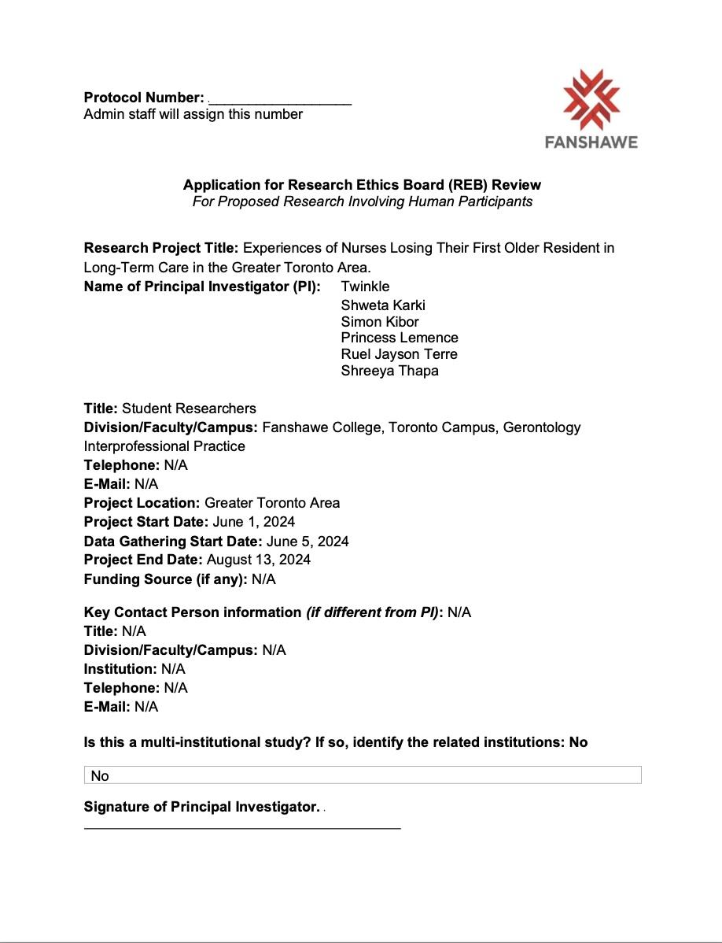

# 

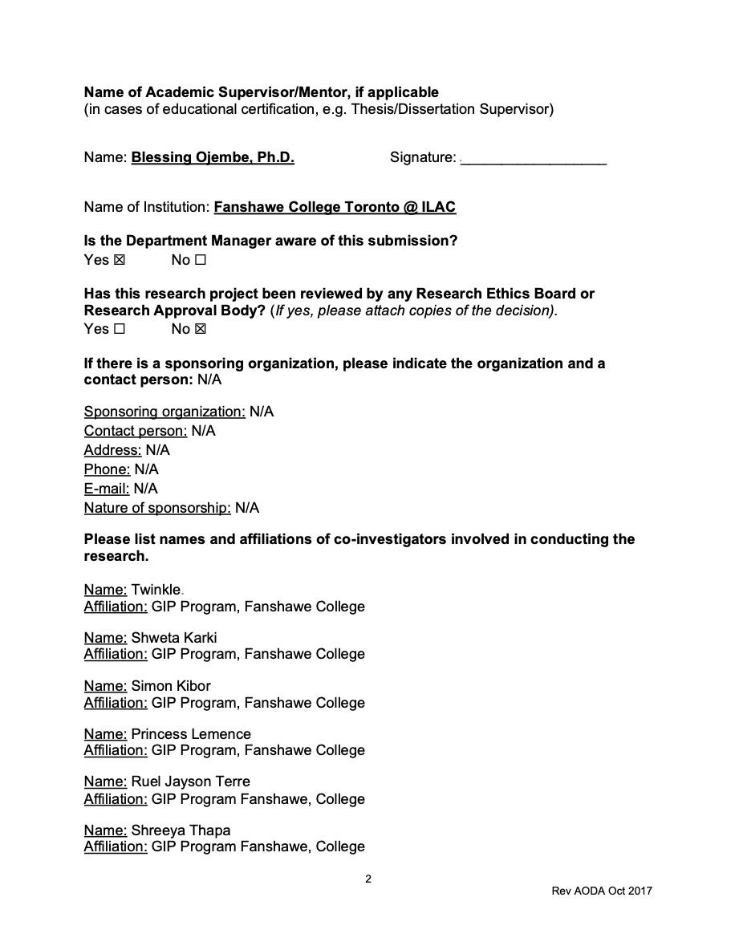

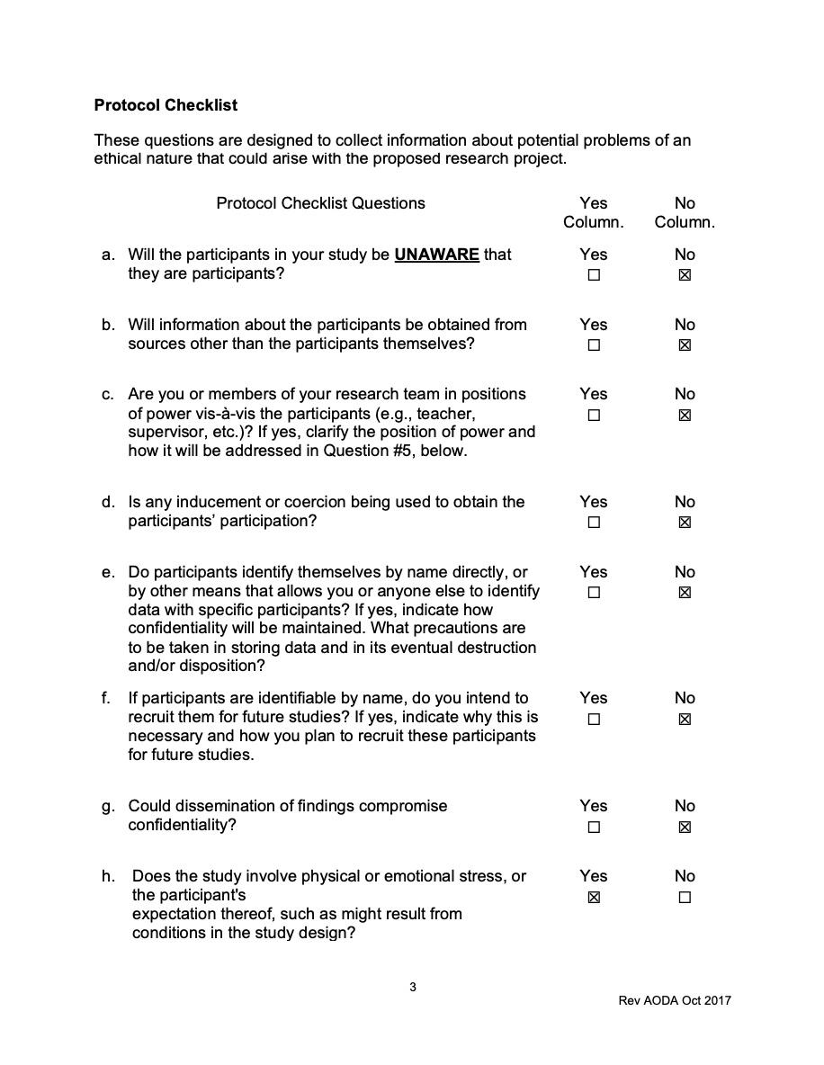

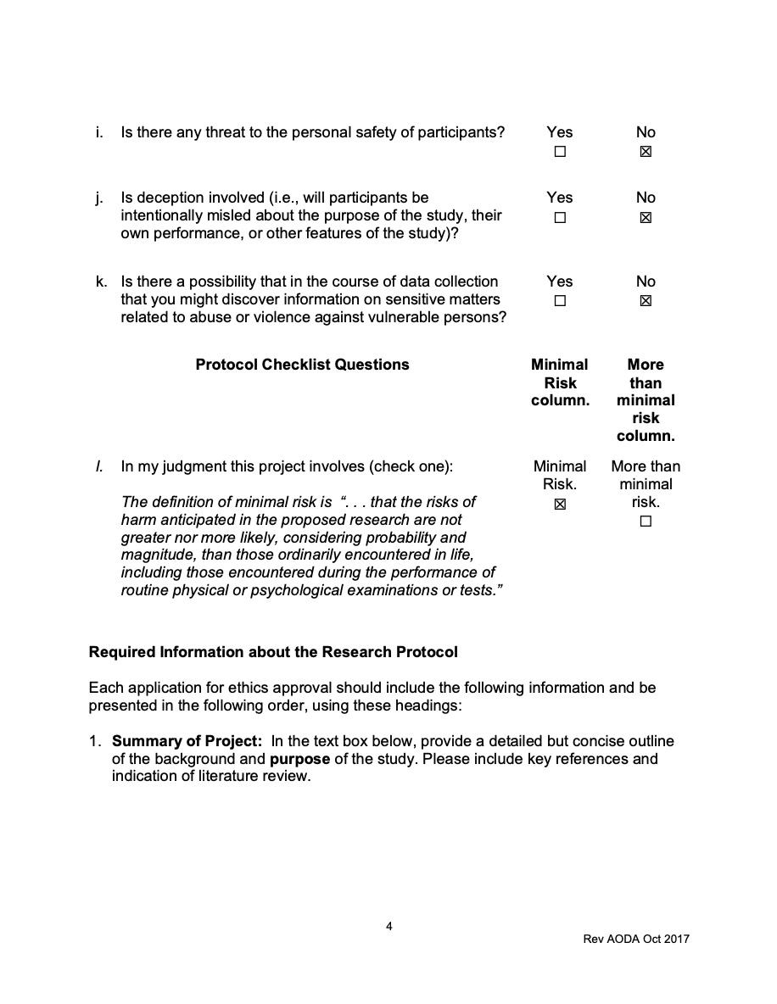

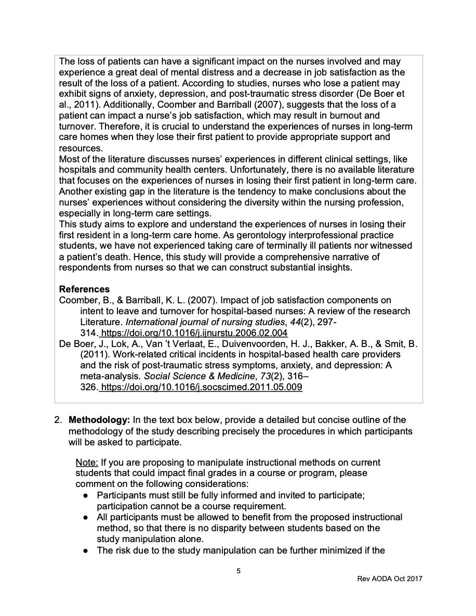

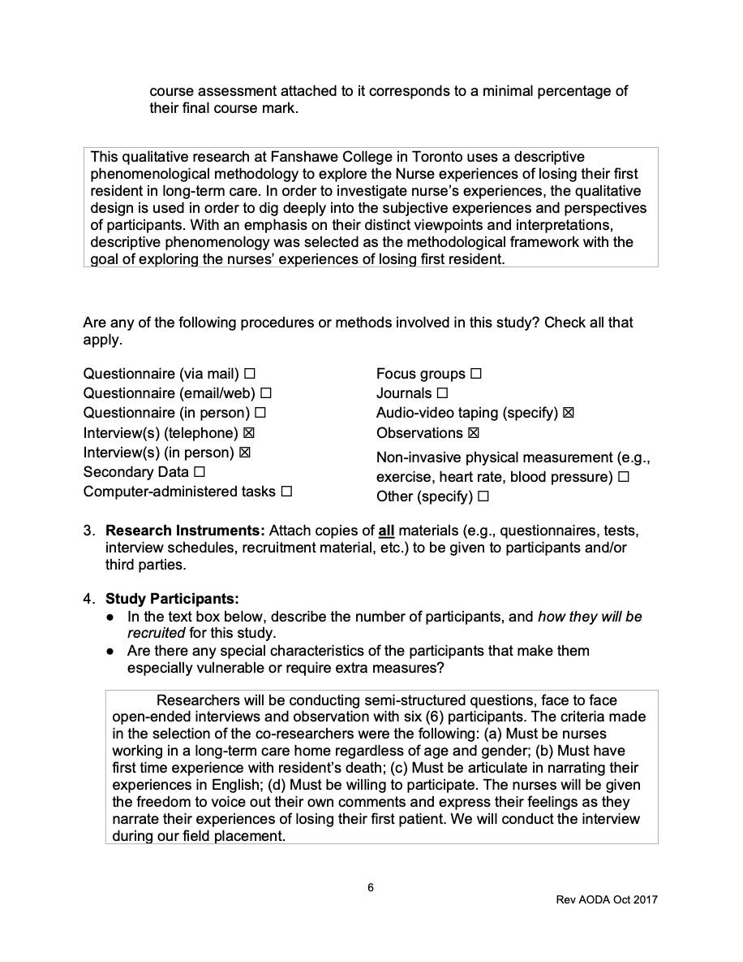

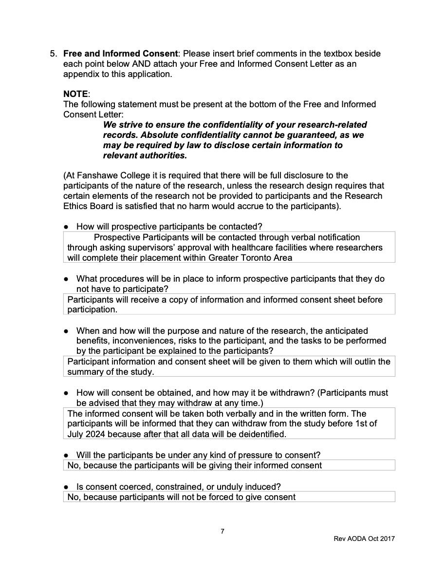

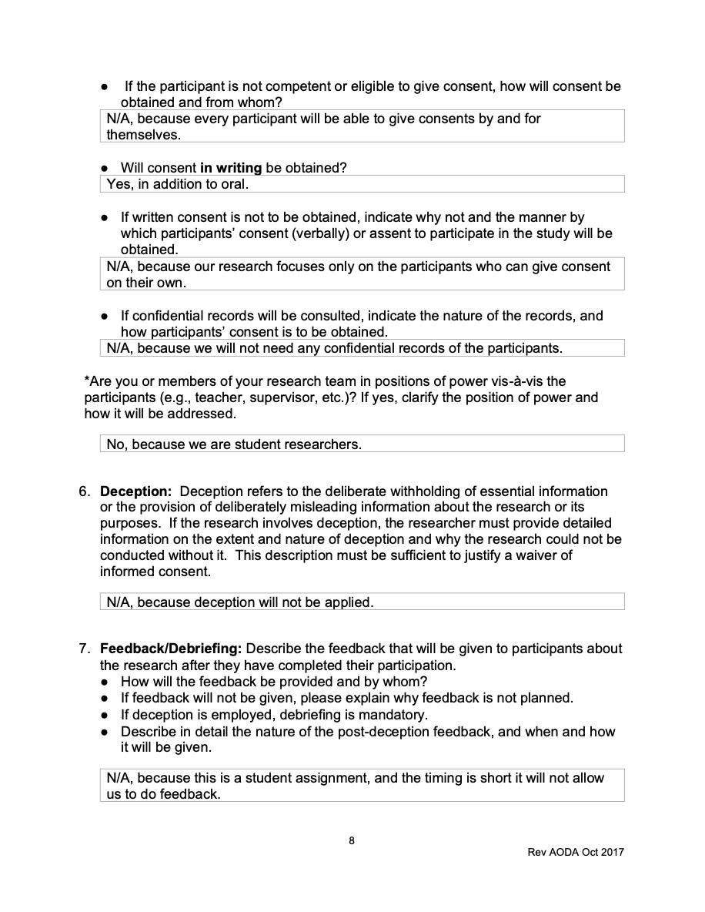

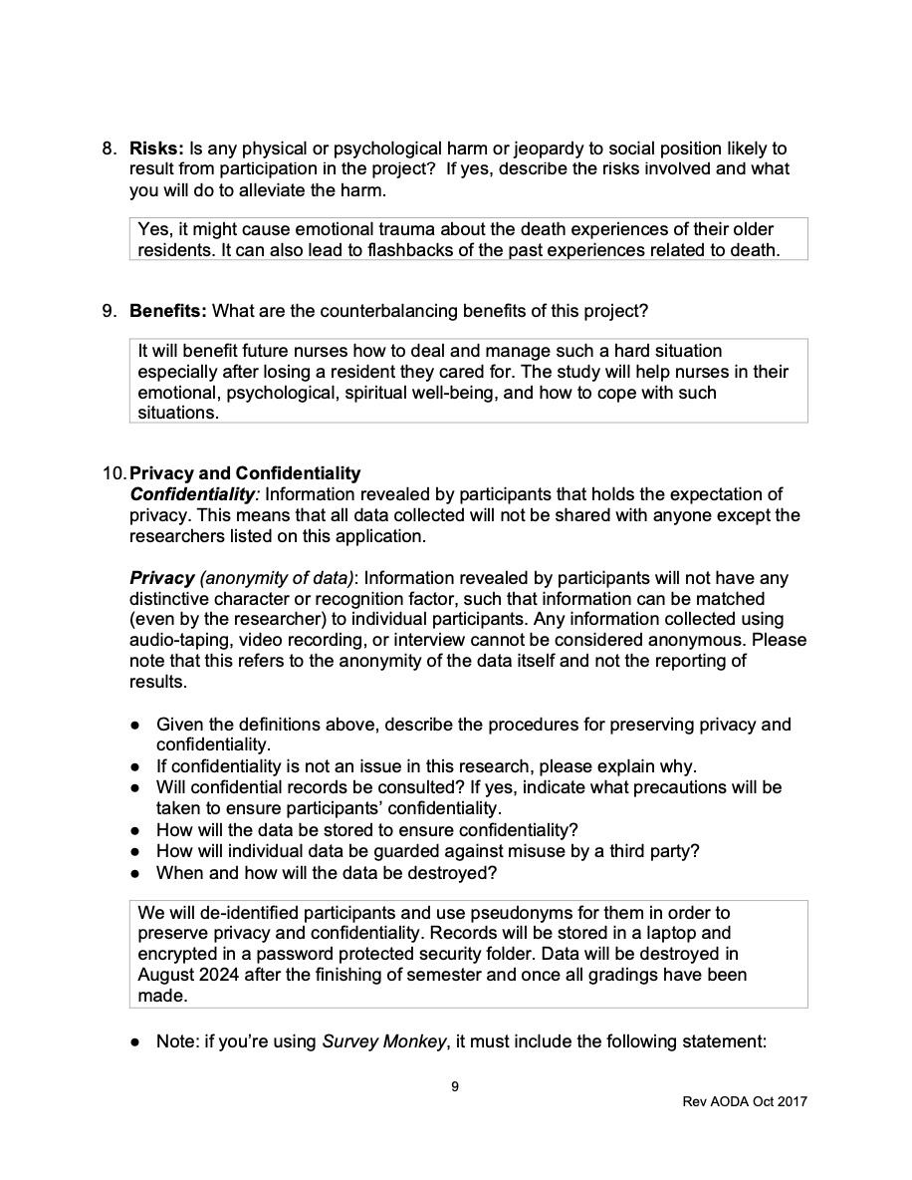

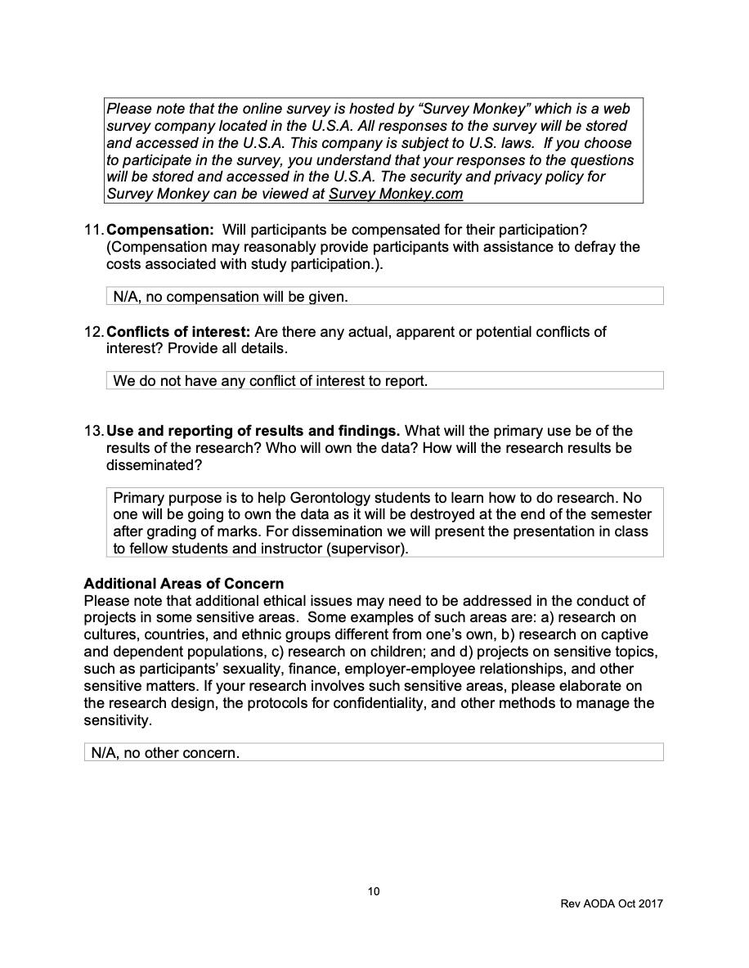

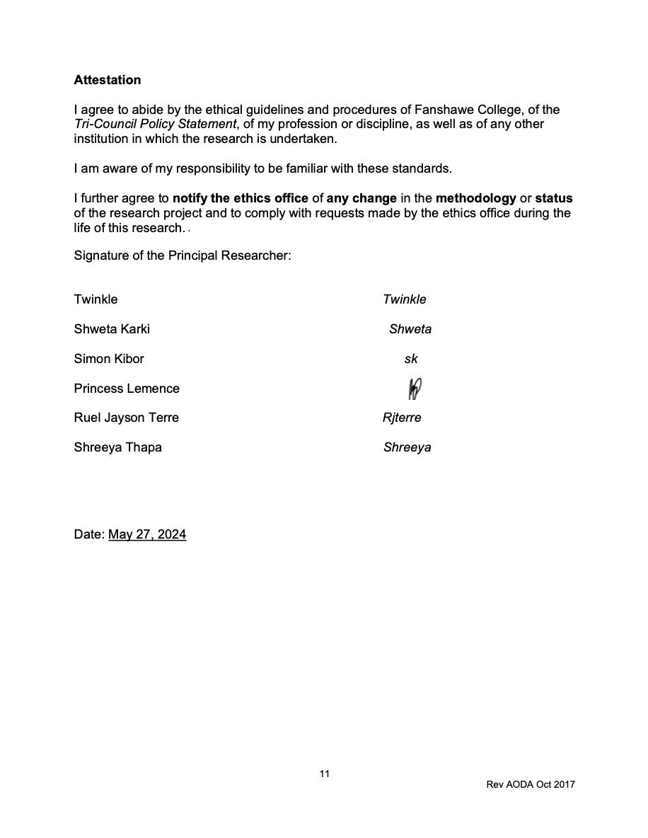

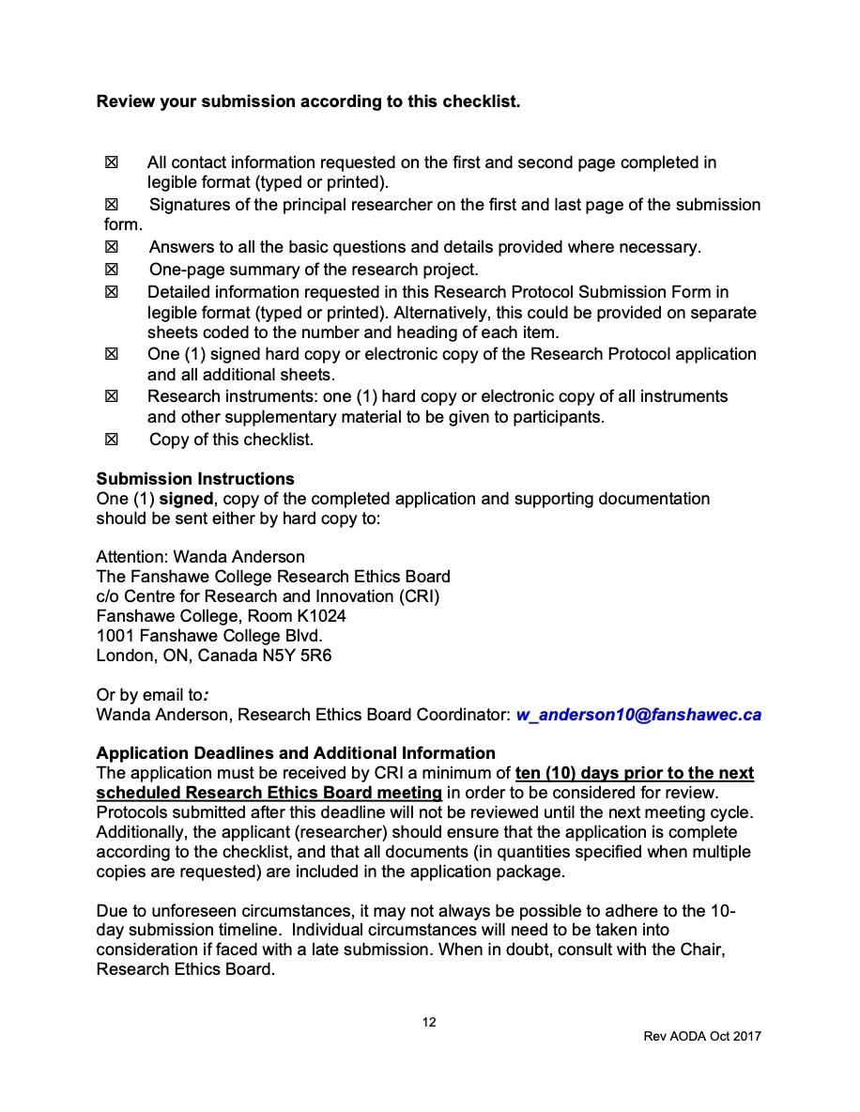

**APPENDIX**

**Recruitment Materials – flyers**

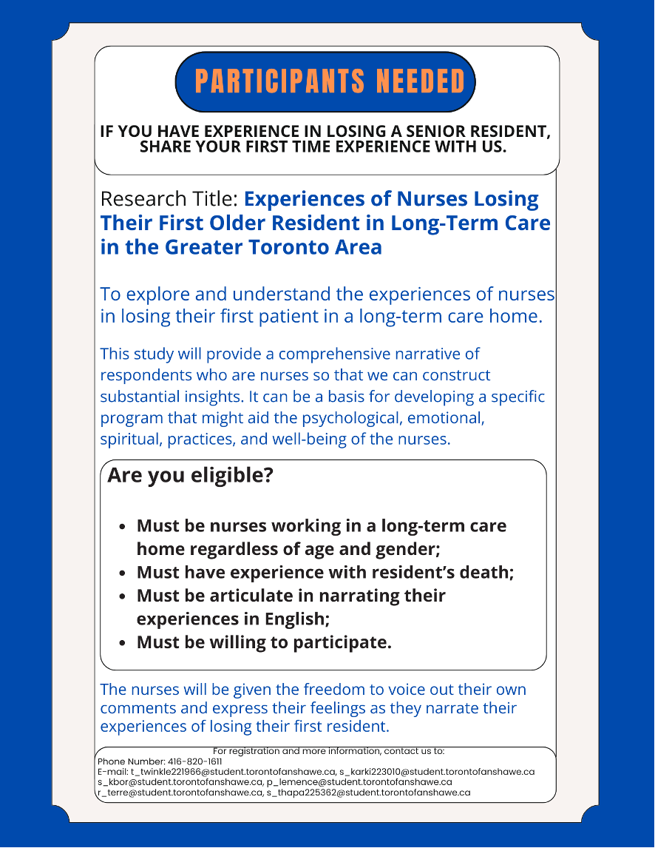

**APPENDIX B**

**Demographic Information Sheet**

| **Sr. No.** | **Demographic Information for Nurse** | |
| --- | --- | --- |
| 1 | How old are you? | * <20 * 21-30 * 31-40 * 41-50 * 51-60 * >60 |
| 2 | Which sex you were assigned at your birth on your original birth certificate? | * Male * Female * I prefer not to say |
| 3 | What is your highest level of education? | * Diploma * Bsc * Msc * PhD * Others, please specify __________ |
| 5 | How many months/years have you been working in this long-term care? |  |

**APPENDIX C**

**Letter of Information / Consent**

**Experiences of Nurses Losing Their First Older Resident in Long-Term Care in the Greater Toronto Area**

**Student Principal investigators: Faculty Supervisor:**

**Names: Twinkle, Shweta Karki Name: Blessing Ojembe, Ph.D.**

**Simon Kibor, Princess Lemence Research Supervisor**

**Ruel Jayson Terre, Shreeya Thapa Gerontology Interprofessional Practice,**

**Gerontology Interprofessional Practice, Fanshawe College, Toronto Campus**

**Fanshawe College, Toronto Campus**

**E-mail: E-mail:**

**t_twinkle221966@student.torontofanshawe.ca b.ojembe@torontofanshawe.ca s_karki223010@student.torontofanshawe.ca**

**s_kbor@student.torontofanshawe.ca**

**p_lemence@student.torontofanshawe.ca**

**r_terre@student.torontofanshawe.ca**

**s_thapa225362@student.torontofanshawe.ca**

**Purpose of the Study**

**This study aims to explore and understand the experiences of nurses in losing their first patient in a long-term care home. As gerontology interprofessional practice students, we have not experienced taking care of terminally ill patients nor witnessed a patient’s death. Hence, this study will provide a comprehensive narrative of respondents who are nurses so that we can construct substantial insights. Likewise, substantial insights can be a basis for developing a specific program that might aid the psychological, emotional, spiritual, practices, and well-being of the nurses. This research is part of the requirements for our assignment at Fanshawe College Toronto and we are under the supervision of Prof. Blessing Ojembe, Ph.D.**

**What will happen during the study?**

**During the interview, our discussion will focus more on the experiences of nurses in losing your first resident. Before I start the interview, I will collect your demographic or background information such as age, gender, educational background, and years of experience working in a long-term care facility. Only one interview session will be conducted with you that works for your availability either in-person or by phone. During this interview session, you will have the opportunity to tell me a detailed story about experience of losing an older resident, perception of first-time experience of death with older resident, your coping strategies and recommendations. The interview will last for approximately 30-45minutes.With your permission, I will record the interview using an audio recording device. This will allow me to gather information and not miss or forget important information that needs to be reported. You are free to choose any platform you prefer – telephone or face- to- face interview. Please feel free to contact me to make the best arrangement for you (email: p_lemence@student.torontofanshawe.ca. Some of the questions I would be asking you include:**

**· Tell me about your understanding of the concept of losing/death of your first older resident? What does it mean to you?**

**· Can you tell me about your first experience in losing your first older resident in a long-term care home. What did it feel like?**

**· Can you remember a particular time about that experience?**

**· How do you think your experience in dying can affect or has affected your professional life and how you manage it?**

**· What will you recommend to other nurses about coping strategies when dealing with the death of an older resident?**

**Are there any risks to doing this study?**

**What will you do to alleviate risk? Talk about this the brochure!**

**There are relatively few risks associated with this study. You could have a mild to moderate risk of emotional disturbances because flashbacks may occur in the death experience. It is our duty to refer you to Canadian Mental Health Association (CAMH) hotline 1800-463-2338.This study will use In-person or telephonic interviews using audio recorders to collect data. There is no other risk involve, as every information received from you will be kept confidential, secured and accessible only to principal investigator. Therefore, taking part or not taking part in this study will not affect your status in any way. While participation in the study is voluntary, you can still decide to skip an uncomfortable question. You may withdraw from the study at any point between the interview to July 1, 2024, when we supposed to begin data analysis.**

**Are there any benefits to doing this study?**

**This study has a direct impact on nurses as it might gain them insights on how to deal with death experience. This could be a foundation for creating a particular program that might support nurses' practices psychological, emotional and spiritual health.**

**There is no direct benefit to you, but I hope that my study will inform research, policy, and practice on experiences of nurses losing an older resident. This could help ensure emotional support, professional development and advancing gerontology knowledge in promoting compassionate care to creating better support systems, training programs and policies benefiting nurses during the end-of-life care.**

**Who will know what I said or did in the study?**

**We will not use your real identity when we disclose the study's findings, and the students have the only ones with access to the data. We will provide a pseudonym before the interview sessions commence. Any of your personal information, particularly the transcript of your interview will be kept private, and a computer protected by a password that is secured and only group members and our professor can access it. We will discard the data on August 20, 2024, when the program is completed.**

**What if I change my mind about being in the study?**

**Participation in the study depends upon a person's will whether they want to be part of it or not. You can withdraw from the interview for any reason even after giving the consent or throughout the study but not after July 1st, 2024. Because after this date we will start our data analysis and it will not be possible to extract the data that belongs to you. There are no consequences for you if you decide to withdraw from the study. You can skip any question during an interview if you don't want to answer, it will not affect your participation in the study.**

**How do I find out what was learned in this study?**

**After collecting your data, we will rewrite the answers in our own words. We expect to have this study completed by approximately August 20, 2024. Kindly let me know if you need a copy of the summary and how you would like it sent to you. If you have any further questions, please feel free to reach out to us.**

**Questions about the Study: If you have questions or need more information about the study itself, please contact us at: t_twinkle221966@student.torontofanshawe.ca**

**s_karki223010@student.torontofanshawe.ca**

**s_kbor@student.torontofanshawe.ca**

**p_lemence@student.torontofanshawe.ca**

**r_terre@student.torontofanshawe.ca**

**s_thapa225362@student.torontofanshawe.ca**

**or 416-820-1611.**

**This study has been reviewed by the Fanshawe Ethics Review Board and received ethics clearance. If you have concerns or questions about your rights as a participant or about the way the study is conducted, please contact:**

**The Fanshawe College Research Ethics Board**

**c/o Centre for Research and Innovation (CRI)**

**Fanshawe College, Room K1024**

**1001 Fanshawe College Blvd.**

**London, ON, Canada N5Y 5R6**

**Or by email to*:***

**Wanda Anderson, Research Ethics Board Coordinator:w_anderson10@fanshawec.ca**

**______________________________________________________________________________**

**CONSENT**

**Before the interview, you will be asked the following questions to candidates and in order to get consent for eligible candidates.**

**Do you agree to take part in this research?**

**If yes,**

1. **Would you like a copy of the study results? If yes, where should we send them (email, mailing address)?**
2. **Do you agree to audio and recording?**
3. **Do you wish to be identified in the report/results? What pseudonym would you prefer?**
4. **Do you agree to allow the use of your anonymized transcript data for knowledge translation during our presentation?**

**If no, “Thank you for your time.**

**Project Title: Experiences of Nurses Losing Their First Older Resident in Long-Term Care in the Greater Toronto Area**

**Lead Researchers:**

**· Twinkle, GIP Student, Fanshawe College, t_twinkle221966@student.torontofanshawe.ca**

**· Shweta Karki, GIP Student, Fanshawe College, s_karki223010@student.torontofanshawe.ca**

**· Simon Kibor, GIP Student, Fanshawe College, s_kbor@student.torontofanshawe.ca**

**· Princess Lemence, GIP Student, Fanshawe College, p_lemence@student.torontofanshawe.ca**

**· Ruel Jayson Terre, GIP Student, Fanshawe College, r_terre@student.torontofanshawe.ca**

**· Shreeya Thapa, GIP Student, Fanshawe College, s_thapa225362@student.torontofanshawe.ca**

**I have read the explanation about this study. I have been given the opportunity to discuss it and my questions have been answered to my satisfaction. I understand that I have been asked to take part in assessing the knowledge of a Nurse. Also, I agree to provide consent for the researchers to access my data set related to my care goal. My participation is voluntary, and I understand that I am free to withdraw from the study at any time, until July 1, 2024, after the observation is complete.**

| **____________________** | **_____________________** | **____________________** |
| --- | --- | --- |
| **Participant Name** | **Signature** | **Date** |

**Options**

**I agree to participate in this research.**

**o Yes**

**o No**

| **____________________** | **_____________________** | **____________________** |
| --- | --- | --- |
| **Name** | **Signature** | **Date** |

**You have the option to agree to participate in any care observations. Additionally, you have the freedom to change your decision about participating at any point, even after initially giving your consent.**

**I agree to participate in this research.**

**o Yes**

**o No**

| **____________________** | **_____________________** | **____________________** |
| --- | --- | --- |
| **Name** | **Signature** | **Date** |

**Please provide an email address below if you would like to be sent a summary of the study results.**

**Email address: ______________________**

**APPENDIX D**

**Interview Questions**

**Preamble**

**Semi-structured Interview**

**We want to ask you, have you ever witnessed the death of an elderly resident? We also want to know about your experience dealing with that for the very first time and how you managed and coped with it. This information will help us to know how death affects a nurse’s professional life. In this way, we will have an in-depth understanding of your experiences. We will be audio-recording the conversation and store it in a password-protected computer for the duration of 5 months. At any point you want to stop the conversation we will respect it and at any time we will continue the interview whenever you are ready. If you have something you do not want to be audio-recorded, we can turn off the audio-recorder. You can also tell me afterwards if there is something you want to remove from the audio-recording. Your response will be kept private, and no presentations and publications will be made without your consent.**

**See some of the questions that would be asked include:**

**Perception of first-time experience of death with older resident**

1. **Can you tell me a little bit about yourself?**
2. **Tell me about your understanding of the concept of losing/death of your first older resident? What does it mean to you?**

**Experience of losing older resident**

1. **Have you witnessed any of your patients dying before in the hospital or LTC?**
2. **Can you tell me about your first experience in losing your first older resident in a long-term care home. What did it feel like?**
3. **What has been the best and worst part in witnessing the death of an older resident under your care?**
4. **Can you remember a particular time about that experience?**
5. **What makes that particular moment stand out for you? Why is it so significant to you?**
6. **Looking at those times when you lost your first older adult in long term care, can you describe what you did to make the experience better or worse?**

**● Like what you did to help yourself feel less or sadder?**

**Coping Strategies and Recommendations**

1. **How did you manage to deal with the deceased family members after the death of their loved one?**

**● How did the family perceive you after you were in charge during the loss of their loved one?**

1. **How did you get emotional support from your experience in losing your first older resident?**

**· What kind of emotional assistance did your employer offer you after your resident passed away?**

1. **How do you think your experience in dying can affect or has affected your professional life and how you manage it?**
2. **What will you recommend to other nurses about coping strategies when dealing with the death of an older resident?**

**Conclusion**

1. **Is there something important we forgot to address?**

**● Is there anything else you think I need to know about your experience in losing the first older resident?**

**APPENDIX E**

**​​Screening Tool**

| **Screening tool for inclusion for older adults** | |
| --- | --- |
| Thank you for indicating interest in participating in this study. Before proceeding, I will need to ask you some specific questions to determine if you can participate in this study. | |
| 1. Are you a registered nurse? | * Yes * No |
| 1. Can you communicate in English? | * Yes * No |
| 1. Are you working in long term care? | * Yes * No |
| 1. Have you ever witnessed the death of an older resident while working in a long-term care home? | * Yes * No |
| 1. If yes, are you able to recall the first death you encounter there? | * Yes * No |
| 1. Are you comfortable to be interviewed for at least 30-45 minutes? | * Yes * No |